Chapter 7, Problem 92.

To move a spot of a cathode-ray tube across the screen requires a linear increase in the voltage across the deflection plates, as shown in Fig. 7.151. Given that the capacitance of the plates is 4 nF, sketch the current flowing through the plates.

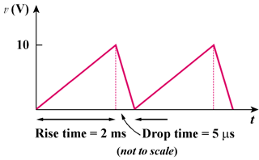

Figure 7.151
For Prob. 7.92.

